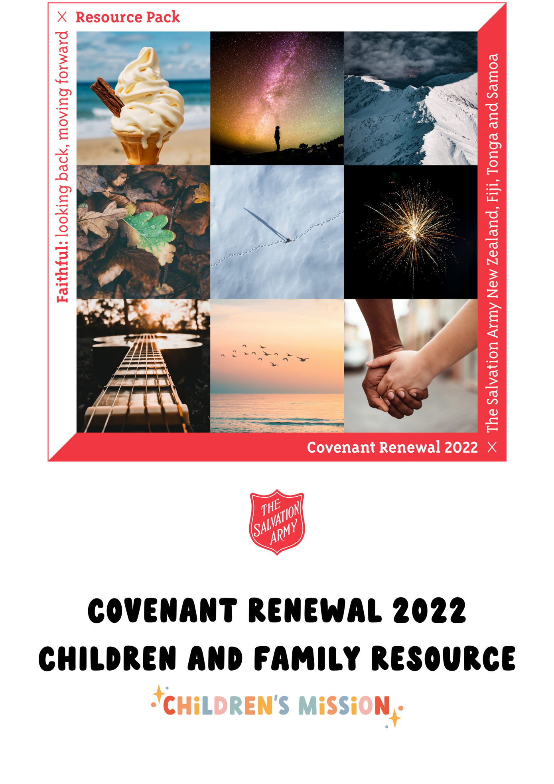

Faithful – Looking Back, Moving Forward
  - Covenant Renewal 2022

Notes for Leaders
Welcome to the Children and Family Resource for Covenant Renewal 2022. Although this has been created with children and families in mind, there is no reason why this could not be used to create an intergenerational experience with everyone in together.
Make sure you add your own creativity and make this a significant time of reflection and response for your corps family.

Theme
This year’s theme – Faithful: Looking back, Moving Forward – is based on Psalm 77:10-15.
The ideas in this resource help us to think about the times when God has been faithful in the past and to understand that, as we move forward, God will continue to be faithful.

Before you begin
We would encourage your team to spend a few minutes praying in your space before the service or programme begins. You could also extend the invitation to your senior leadership team and other members of your corps / centre. If you have time it would be great to pray for each child by name and ask that God speak to them.

Engaging with Scripture

Introduction
Often when it comes to engaging with Scripture, we want to find a story to share. However, the passage of scripture that has been selected for Covenant Renewal 2022 is from the Psalms. This is a wonderful opportunity for our families to engage with this part of God’s Story.
Creative Story-telling and Props ideas
- Set up a blow-up boat, oars, life jackets. You might choose to sit yourself amongst these items. These items represent our theme, Faithful: Looking back, moving forward. When you row a boat, you are not only moving towards your destination, you are also looking back. You are ‘backing into the future’.
- Create a faux campfire, with picnic blankets, bean bags, cushions around it. Maybe even marshmallows on sticks. This is significant as, at the time of Psalm 77 (our passage of scripture) being written, like for many today, fire was a symbol of God’s presence and faithfulness. God’s Spirit had led and guided the Israelites in the form of fire throughout their history (eg. The burning bush, the pillar of fire). And, the story of God and His people, the Israelites, would have been passed down generation to generation orally – perhaps as stories around campfires??!
You could pretend to boat to the camp site and then get the children to get comfortable around the campfire.
Get Thinking
Ask children an appropriate question from the list below or come up with your own, being sensitive to children who may not be able to answer based on positive experience, eg. if they come from a household experiencing food insecurity. The idea is to help children give a confident response based on their previous experiences. They can ‘predict’ their future based on what they know from their past.

“Who thinks that they will have breakfast tomorrow?”
“Who thinks that they will have to go to school tomorrow?”
“Who knows what will happen after Kids’ Church today?”

Then ask children how or why they know that, and how certain they are. They are likely to respond with something similar to this idea; that they know because that is what has happened in the past/what always happens. They have faith, or a certainty, in their routine! Today, we will hear from a Psalmist who had faith during uncertain times because they remembered the faithfulness of God.
Read the Bible
As a leader, take some time to research the scripture and how it came to be and the story of the Israelites up to this point. Remember as you look at this scripture to explain the rowing analogy; backing into the future – looking back while moving forward. This analogy helps us understand how being reminded of God’s faithfulness gives us an assurance about our future, because we can trust God.
Then read Psalm 77:10-15. We like the version found in NIrV or CEV as we open this Bible passage with our children. Since the Psalms were written as songs, you might choose to have instrumental worship music playing softly behind. This might invoke some of the feeling of it being a song, rather than you having to find a way to sing the words!!
Then I thought, “Here is what gives me hope.
For many years the Most High God showed how powerful he is.
Lord, I will remember what you did.
Yes, I will remember your miracles of long ago.
I will spend time thinking about everything you have done.
I will consider all your mighty acts.”
God, everything you do is holy.
What god is as great as our God?
You are the God who does miracles.
You show your power among the nations.
With your mighty arm you set your people free.
You set the children of Jacob and Joseph free.
Psalm 77:10-15 (NIrV)
Testimony
Invite an older young person or an adult to come and share about one of the scenarios below. We suggest that you might invite them to use visual props to help children dive into the story. It’s also a good idea to give them an idea of how long you have allocated for this part of the session!
  - A time when remembering how God had been faithful to them in the past helped them to feel confident about their future.
  - Or, a time when remembering how God had been close to them in the past helped them see how God was with them in the present.
Wonder Together
Ask these questions, inviting children to ponder them. They can share aloud if they wish too, however if this is a new practice for them, that might feel intimidating. Sometimes it’s scary to share aloud if we don’t know that there is no secret right or wrong answer. That’s okay too. We trust that the Spirit is ministering to the children directly.
  - I wonder how the Psalmist/writer of Psalm 77 knew that God is mighty.
  - I wonder if you have ever seen, or heard about, a miracle from God.
  - I wonder if you know what it feels like to find hope in God, the Creator of the Universe.

Response Time Ideas
The Story of God and Me drawings
Print a copy of the ‘Story of God and Me template’ for each person – children and adults alike (some adults or young people might like more boxes as they have had more years of life).
Each person is invited to draw in the boxes the story of their life, showing when God has come close to them, been with them or has been faithful to them. Provide coloured pencils or felt pens!
If this is too difficult for some, instead they could think about and draw when they have experienced or encountered beauty, truth and goodness throughout their life.
Allow time and opportunity for participants to share with the group, or each other, about their story with God.
Holy Listening Stones
Holy Listening Stones are a resource you can easily make yourself. They are used in a similar way to symbol cards, but the emphasis is on creating a sacred moment that God is invited into.
See here for more info: Simple Directions to Make Holy Listening Stones (leanne-hadley.com)
Make a set of Holy Listening stones (or a few sets if you plan to use these in small groups). Invite each participant to choose a stone that represents God’s faithfulness or closeness for them – this might involve a story of God’s faithfulness from their own life. Then give an invitation for each person to share about the stone they chose. If it suits, you might choose to let people take their stone home to keep in their pocket or next to their bed as a constant reminder of God’s faithfulness.
Story/Symbol Cards
We would encourage this to be done as an intergenerational time, before the children move into their ministry and worship time. Think about the environment that can be created with everyone (no matter what age) considering what symbol card they will choose that represents the faithfulness of God in the past and that God will be faithful in the future.
We have created a set of symbol cards or you might have your own, you could use them in a similar way to the Holy Listening Stones. Invite each participant to choose an image that represents God’s faithfulness or closeness to them – this might involve a story of God’s faithfulness from their own life. Then give each person an invitation to share about the image they chose.

Faith at Home Resource
Faith 5 Family Time
Print a copy of the ‘Faith 5 Family Time template’ on light card for each family/household. This supports families to continue connecting with this message, with God, and with each other at home.
Each night this week, spend ten minutes as a family doing the Faith 5, as a way of connecting with each other, revisiting our Bible story, and listening to what God might be saying!
- Share your highs and lows (high points and low points) of the day with each other.
- Read this week’s Bible passage together – Psalm 77:10-15.
- Talk about how this week’s Bible reading might apply to your highs and lows. (ie. what might God be saying to us today/tonight?)
- Pray for one another’s highs and lows.
- Bless one another before turning out the lights.

Extra ideas for leaders to support families’ Faith 5 experiences at home:
- We encourage you to provide a Bible to families who may not have access to an appropriate one (eg. CEV, NIV) at home. Or suggest an app they could use!
- You might like to provide a lip balm/chapstick that could be used as ‘blessing balm’ for step 5. Families may like to use the “blessing balm” to draw a cross on each other’s hands while saying the blessing. The balm is simply a sensory reminder that while we can’t see God, sometimes we can get a “whiff” of God’s presence. A blessing could be suggested, such as:
  - “May the Lord bless you and keep you. May He smile on you and be gracious to you. May the Lord look you full in your face, and give you His peace. Amen.”
  - (Name), you are God’s child. He loves you, and He is always with you. Thank you, God, for (Name).
- Perhaps you could provide a battery-powered tealight candle for each family. They can turn this on at the beginning of their Faith 5 Family Time as a reminder of God’s presence with them.

